Determination of Concentration of Sucrose in Unknown Solution, Diet Beverage, and Regular Beverage by Polarimetry

Max Shi

*Department of Chemistry, Stevens Institute of Technology, Castle Point on Hudson, Hoboken, NJ 07030.*

*Performed November 2, 2020, submitted November 10, 2020.*

**Abstract**: In this experiment, polarimetry was used to determine the concentration of sucrose in three unknown solutions: a solution of sucrose in water, a diet beverage, and a regular beverage. This takes advantage of the chirality and optically active property of sucrose, to measure the angle of rotation in solutions of different concentrations. After creating five calibration solutions of 1.0%, 2.0%, 4.0%, 6.0%, and 8.0% w/v, their rotations were measured with a polarimetry cell with a path length of 10 cm and a light wavelength of 589 nm. From the calibration curve, the specific rotation of sucrose was experimentally calculated to be 65.17 deg*mL*g-1*dm-1. Then, the unknown solutions were measured with the polarimeter, and the measured rotation of the three unknowns were 3.252, 2.663, and 0.067 degrees, respectively. Plugging this into the regression equation recovers a w/v percentage of 4.99%, 4.09%, and 0.11% respectively.

**Introduction**

Polarimetry is a technique used to measure the rotation of plane polarized light by a solution, which then can be used to determine the concentration of an unknown compound by standard ordinary linear calibration. This technique takes advantage of the optically active property of chiral compounds and their capacity to rotate plane polarized light based on the concentration of the solution and the path length of the polarimetry cell in which the solution is loaded in, according to Equation 1.

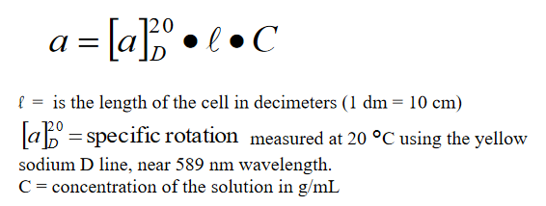

Equation 1: Biot’s Law

The polarimeter emits light through a polarizer, which plane polarizes the light. This light is then passed through the polarimetry cell, and then another polarizer at the end of the cell is rotated to attain the maximum transmittance through the second polarizer. The amount the second polarizer rotates is the measured rotation of the sample, and is displayed in the machine.

In this experiment, the chiral compound in question is sucrose, a sugar used to flavor drinks, shown in Figure 1. This compound is optically active, and according to Biot’s law, the rotation is directly proportional to concentration. Therefore, to find the concentration of sucrose in the three unknowns, standard ordinary linear calibration can be used with multiple calibration solutions to generate a calibration plot of measured rotation against concentration. Measuring the rotation of the samples and plugging those values into the regression equation will recover the unknown concentration.

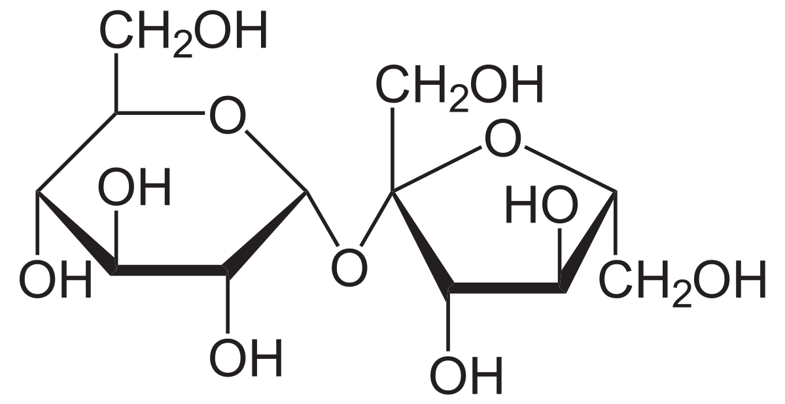

Figure : Structure of Sucrose

**Experimental**

Sucrose (CAS#: 57-50-1), the unknown sucrose solution, the diet beverage, and the regular beverage were all provided by the TAs. The polarimeter used for the experiment was a Rudolph Autopole IV Polarimeter.

To begin, sucrose (25 g) was accurately measured out and dissolved into deionized water in a 250-mL volumetric flask to create a 10% w/v stock solution of sucrose. Then, to produce five calibration solutions of 1.0, 2.0, 4.0, 6.0, 8.0% w/v solutions, 5.0, 10.0, 20.0, 30.0, and 40.0 mL of the stock solution was transferred into five 50-mL volumetric flasks and diluted to the mark with deionized water. Then, for each calibration solution, the polarimetry cell was filled and the rotation was measured. From the measurements, the following calibration plot was generated, depicted in Figure 2.

Figure : Linear Calibration Plot of Sucrose

Using the slope of the regression equation, the path length, which was 10 cm, or 1 dm, and 100% w/v, or 1 g/mL, plugging into Biot’s Law and solving for specific rotation recovers a rotation of 65.173 deg*mL*g-1*dm-1. This is comparable with the actual value of the specific rotation of sucrose at 589 nm, which is 66.5 degrees. Differences could be a result of some impurities in the sucrose, which could lower the rotation of the light, especially if those impurities were the enantiomer of sucrose, which would rotate light in the opposite direction. Another factor could be an inexact wavelength selection from the sodium D lamp, as specific rotation depends on the wavelength of plane polarized light passing through the sample.

To determine the concentration of the unknown solutions, the rotation of the unknown sucrose solution, the regular beverage, and the diet beverage were measured in the same way with the polarimeter. The measured rotations were 3.252, 2.663, and 0.067 degrees, respectively. Plugging each of these values in for y in the regression equation recovers a w/v percentage of 4.99, 4.09, and 0.11, respectively. While this experiment yielded concrete results for the w/v percentage of sucrose in the beverages, modern day beverages manufactured in the United States often use high fructose corn syrup rather than sucrose for the sugary flavor. Because the compounds are entirely different in their optical activity, this method would not work for finding the amount of sucrose in these beverages, as fructose is chiral and effects the measured rotation of the samples. Thus, this is the weakness in this method: presence of other chiral compounds renders this technique useless, as the plane-polarized rotation is additive based on the concentration of chiral compounds in the solution.

References

1. 1920px-Saccharose2.svg.png (PNG Image, 1920 x 991 pixels) <https://upload.wikimedia.org/wikipedia/commons/thumb/1/1a/Saccharose2.svg/1920px-Saccharose2.svg.png> (accessed Nov 10, 2020).
2. Attygalle, A. Instrumental Analysis I Lecture and Laboratory Manual <https://sit.instructure.com/courses/38802/files/6982711?module_item_id=1042514> (accessed Nov 10, 2020).